Dark Souls Boss Database
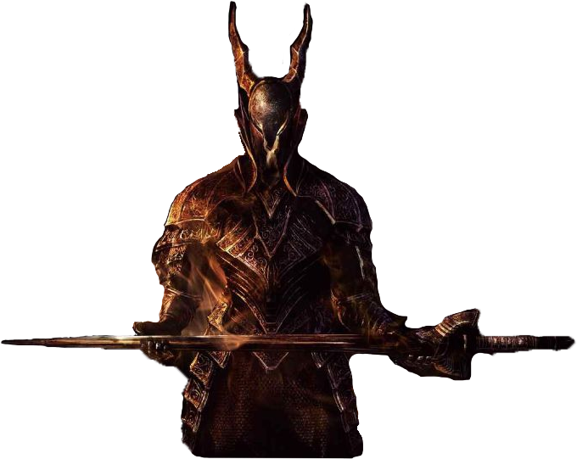

Designed by: Mike Mucci

Table of Contents
Executive Summery……………………………………………………………….3
Entity-Relationship Diagram……………………………………………………...4
Tables: Create Statements, F(n) Dependencies, Sample data………………...5
Location Table…………………………………………………………………….5
Races Table………………………………………………………………………..6
Damage Type Table……………………………………………………………….7
Bosses Table……………………………………………………………………….8
Weaknesses/Resistances Tables…………………………………………………...9
Items Table……………………………………………………………………….10
Offensive Items Table……………………………………………………………11
Defensive Items Table…………………………………………………….……...12
Boss Drops Table………………………………………………………….……...13
Views: Definitions and Sample output………………………………….……...14
Important Boss Information View………………………………………….…….14
Boss Item Drop Information View………………………………………….……15
Offensive/Defensive Item Information View………………………………..…...16
Stored Procedures: Definitions and Sample output……………………….….17
AddItem Procedure…………………………………………………………….…17
Security: Users and Privileges……………………………………………….…19
Administrator/Player Users and Privileges….…………………………………....19
Implementation Notes/Known Problems/Future Enhancements…………….20
Executive summery

Overview
Dark Souls is an action RPG (role-playing game) which takes place in a bleak fictional land called Lordran, which is filled with death a myriad of undead who roam the earth. Anything that breaths has a soul, of which has a certain value. Those undead who do not obtain souls, lose their minds and are called hollow. Undeads are collected and sent to the Undead Asylum, inevitably becoming hollow. However, there is a legend that a chosen undead will leave the Asylum and make way to Lordran to decide the fate of the world.

Objectives
The player takes the role as the Chosen Undead and throughout the story, the player has to defeat a multitude of bosses. The majority of them are very hard and the only way to overcome them is with strategy. The information contained in this database is to help those reading it, whether they be players or anyone else interested in the game, to know as much as possible about the main bosses in the game.

Note: At the end of the game's first play through (NewGame), the player can replay the game but at a higher difficulty, called NewGame+. The differences between NG and NG+ are inconsistent, therefore this database only reflects the data gathered from NG.
Entity-Relationship Diagram
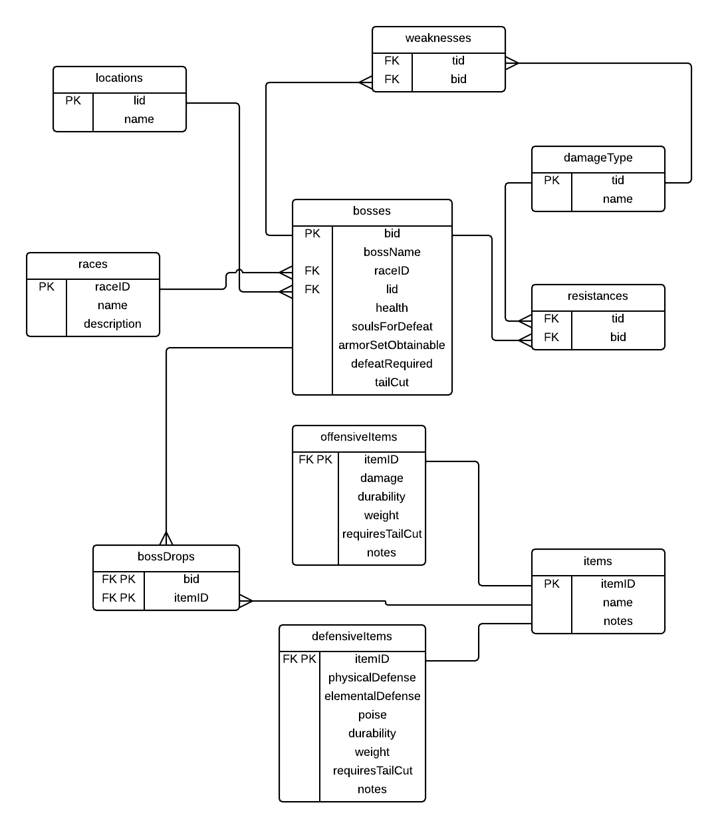

Tables
Locations table
The locations table contains all the locations in the game where a boss can be located. An auto incrementing integer, serial, is used to easily keep the primary key unique.

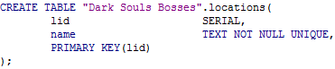

Functional dependency: lid→name

Sample Data:
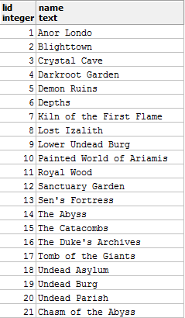

Races table
The races table contains all the races that a boss can be.

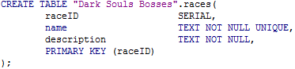

Functional Dependency: raceID→ name, description

Sample Data:
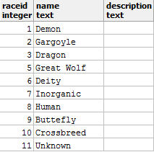

Damage Type table
The damage type table contains the elemental, physical, and status damage types that an attack can do.

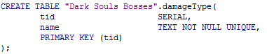

Functional Dependency: tid→name.

Sample Data:
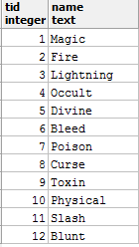

Bosses table
The bosses table contains all the main bosses in the game. Some bosses reappear in the game as common enemies, but as lesser versions of their stronger counterpart; they are weaker and have less health and are thereby excluded.

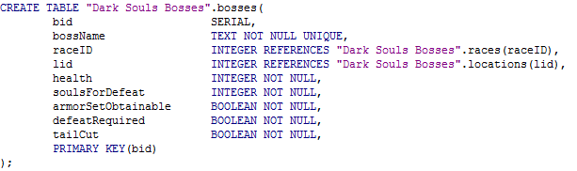

Functional Dependency: bid→bossName, raceID, lid, health, soulsForDefeat, armorSetObtainable, defeatRequired, tailCut

Sample Data:
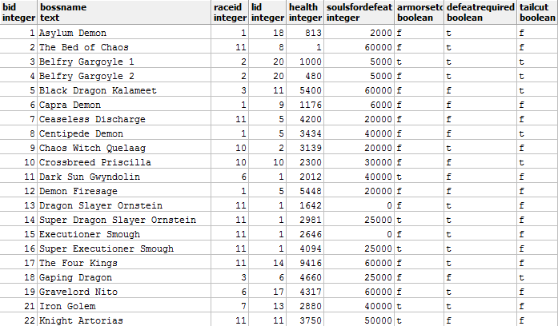

Weaknesses table
This table contains the damage types/elemental weaknesses of the bosses matched by the boss' ID.

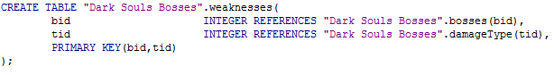
Functional Dependency: bid, tid→
Sample Data:
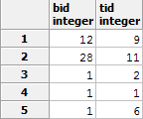
…
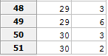

Resistances table
This table contains the damage/elemental resistances of the bosses, again matched by the boss' ID.

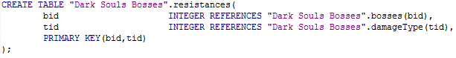
Functional Dependency: bid, tid→
Sample Data:
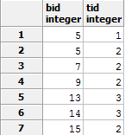
…

Items table
This table contains the all the items that the bosses can drop upon death.

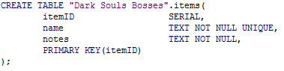
Functional Dependency: itemID→name, notes

Sample Data:
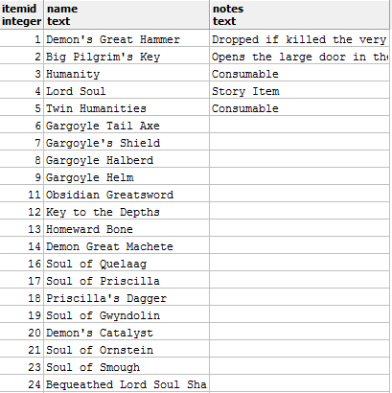
…

Offensive items table
This table contains the information about the offensive items. Offensive items have been categorized as items that can do damage. The ID in this table matches the global itemID in the items table.

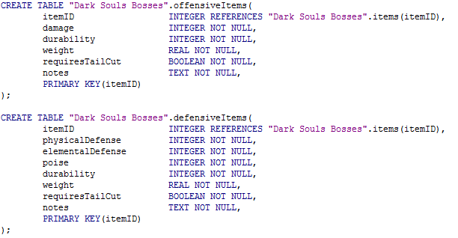
Functional Dependency: itemID→damage, durability, weight, requiresTailCut, notes

Sample Data:
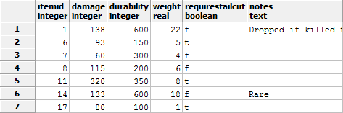
…

Defensive Items table
This table contains the information about the defensive items. Defensive items have been categorized as those that protect against damage.

Functional Dependency: itemID→physicalDefense, elementalDefense, poise, durability, weight, requiresTailCut, notes

Sample Data:
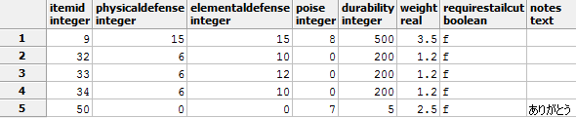

Boss Drops table
This table matches the bosses to what items they drop upon defeat.

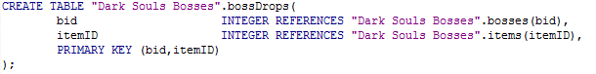

Functional Dependency: bid,itemID→
Sample Data:
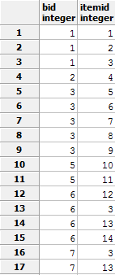
Views
important boss information view
This view allows one to see all the pertinent information about every boss.

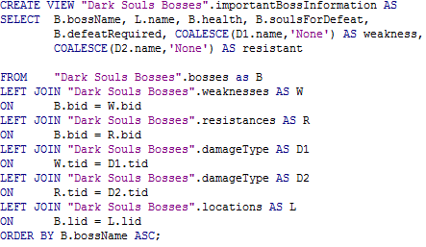
Sample Data:
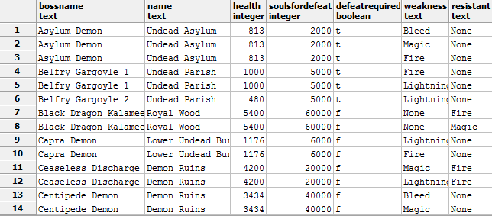

"Duplicates" are present because certain bosses have multiple weaknesses/resistances.

Boss item Drop information view
This view shows what items each boss drops. This is different from the table because this result shows the item's name, for easy readability and no need for manual cross-referencing.

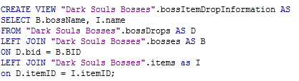
Sample Data:
…
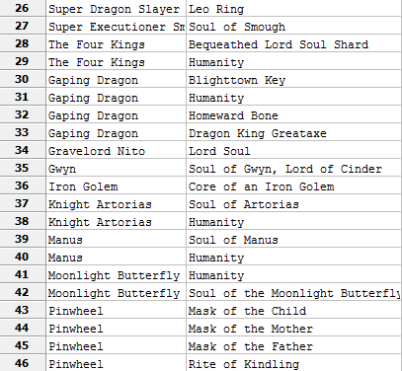
…

Offensive item information view
This view shows the offensive items but with their names' substituted in for the ID's for easy readability.

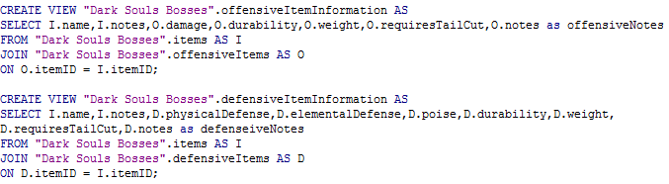
Sample Data:
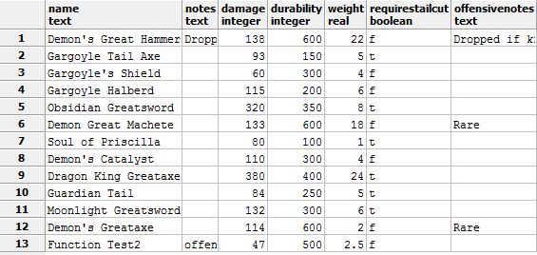

Defensive item information view
This view shows the defensive items with their ID's replaced with their respective names.

Sample Data:
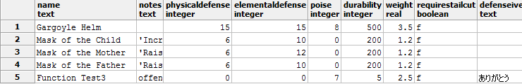

Stored Procedures
Add Item Function (explained on next page)
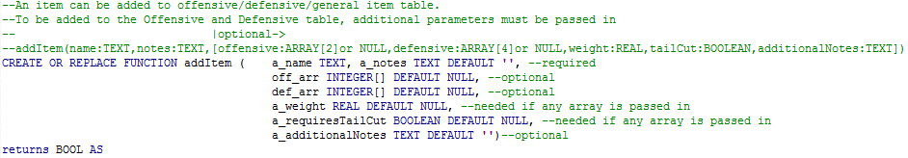

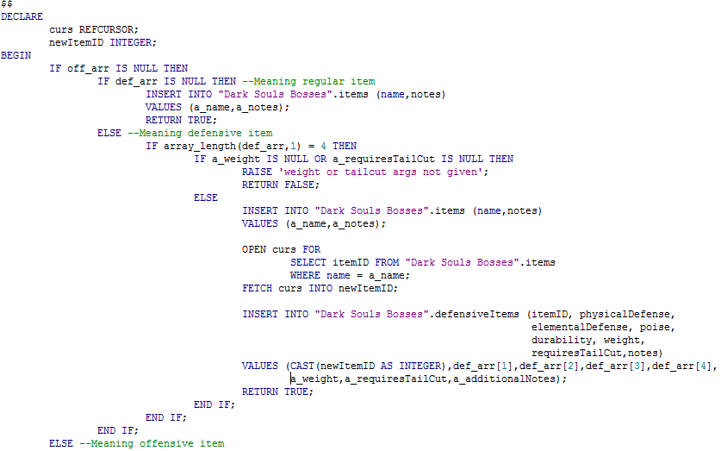

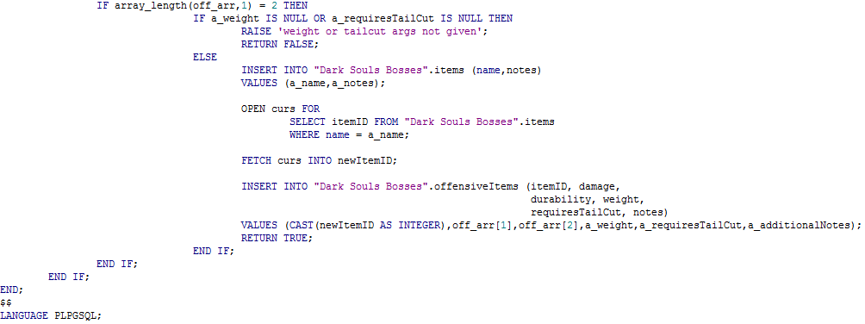

This function allows an admin to add an item while additionally adding data to the offensive or defensive if necessary. If one want to just add an item, then the first two parameters are the only ones that need to be supplied. If offensive or defensive data needs to be added, then the rest of the parameters need to be supplied. Here is the syntax:

addItem(name:TEXT,notes:TEXT,[offensive:ARRAY(2)||NULL, defensive:ARRAY(4)||NULL, weight:REAL, tailCut:BOOLEAN, additionalNotes:TEXT])

Everything within the [ ] is optional, however, if one parameter is passed into one of the optional fields, then the rest are mandatory.
Security

For this database, there would be two types of users:

Admin:
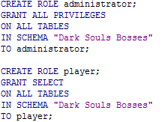

Admin will have the ability to do anything with the database, naturally as the title 'admin' would suggest.

Player (general user):

The player is just able to view the data; no internal manipulation.
Implementation Notes
Implementation went pretty well actually. Along the way, when I was gathering the data, I realized I needed to get more specific with the Items information. Originally I had one items table for every item, but then I realized that offensive and defensive items, in addition to regular consumable items, have different important information attached to them. So the fact that I divide it up into offensive and defensive, I can display more information and improve the usefulness of the database.
I also realized when I was gathering the data on weaknesses and resistances that there's more to these attributes than the normal elements I originally had, like fire and electricity. I expanded the table to just damage types so it would be able to expand and hold different types of damaging effects and not be so restrictive to only elements.

Known Problems
Uhh, it's not implemented in the real world yet. All pretentiousness aside, the only problem I see is that in the defensiveItems table, physicalDefense and elementalDefense represent the average type of damage/defense. There are four different types of physical attacks and three types of elemental attacks. So it's not very specific in that respect.
Also, the addItem procedure doesn't check if both offensive and defensive arrays are passed in. It just adds the item with the offensive stats.

Future Enhancements
I would fix the offensive and defensive tables to include the various types of physical and elemental damage to accurately reflect the item's attributes. Also I would add to the addItem procedure to check if both arrays are supplied and then print out an appropriate response of, "Please insert only one array".
I would also add more notes to the items and bosses to make the database more complete.

